POS_logo_color.emf

**MEMORANDUM**

**TO: COLUMBIA GROUP EXCELLENCE AND EQUITY PROJECT**

**FROM: ROBERT BLIZZARD**

**SUBJECT: ATTITUDES TOWARD EDUCATION IN THE SOUTH**

**DATE: DECEMBER 14, 2017**

**METHODOLOGY**

*In the fall of 2017, Public Opinion Strategies completed a set of focus groups and a survey among registered voters across the South to help determine whether voters recognize the need for greater equity in public schools, ascertain the most effective terminology and messaging around closing gaps and equity in education, and finally, learn how voters want*

*policymakers to take action to help schools.*

***FOCUS GROUPS:***

*In London, KY, one focus group was held on September 21, 2017 among registered voters, and was screened to include a mix of gender and age and a mix of political party affiliations. And, in Atlanta, another focus group was held on September 27, 2017 among registered voters, and was screened to include a mix of gender and age, a mix of ethnicities, and a mix of political party affiliations. Some parents were included in both locales.*

***SURVEY:***

*Public Opinion Strategies also completed a survey of 2,200 registered voters across the South, October 18-25, 2017. The poll was conducted online and has a margin of error of + 1.8%.*

*Fully 200 interviews were completed in each of 11 states (Alabama, Arkansas, Georgia, Kentucky, Louisiana, Mississippi, North Carolina, South Carolina, Tennessee and West Virginia), 100 interviews were completed in Northern Florida and 100 interviews were completed in Southern Virginia. Each state was geographically stratified by county, and other key demographics were pegged to census/voter data for each state.*

**KEY FINDINGS**

***The economy and K-12 public education are top-of-mind issues for voters.***

In the survey, voters rated “improving the economy and creating jobs” and “improving K-12 public education” as the top priorities for their state and local elected officials to address:

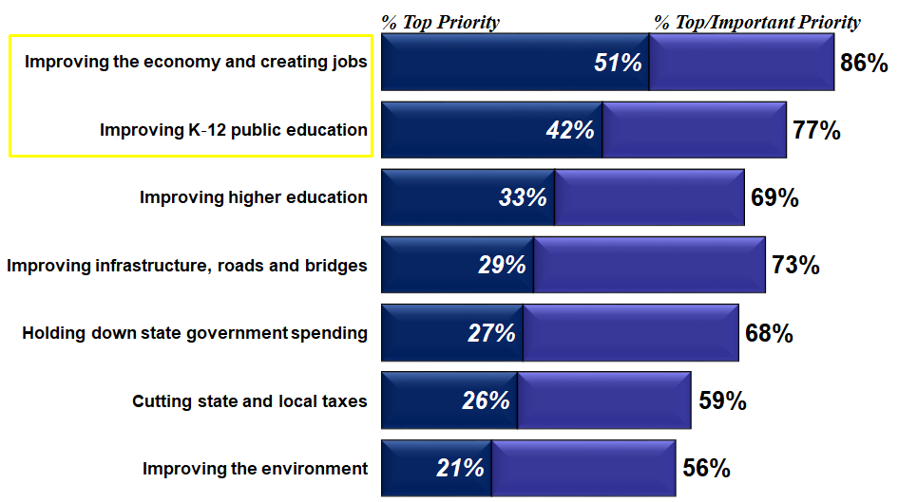

In our focus groups, improving public education is almost immediately brought up organically when voters are probed on what they would like their state and local officials to focus on.

When prompted, voters tend to focus on the lack of school funding, that programs are being cut, and stress the need for more STEM. Further, voters express concern over the lack of vocational training and real world skills training.

In addition, voters – especially in the Atlanta focus group – really hone in on the lack of funding and on spending discrepancies from school district to school district.

***Voters across the South share mixed views about the direction of their local public schools.***

Fully 42% of voters across the South believe the public schools in their local area are generally headed in the right direction, while a similar percentage (39%) believe they are off on the wrong track.

Republican voters are slightly more positive than Independents and Democrats. And, White voters, Suburban voters and Rural voters are also more positive about their local public schools than African-American voters and Urban voters.

Further, few voters believe quality of education is getting better in their local schools, across their state, or even across the entire South:

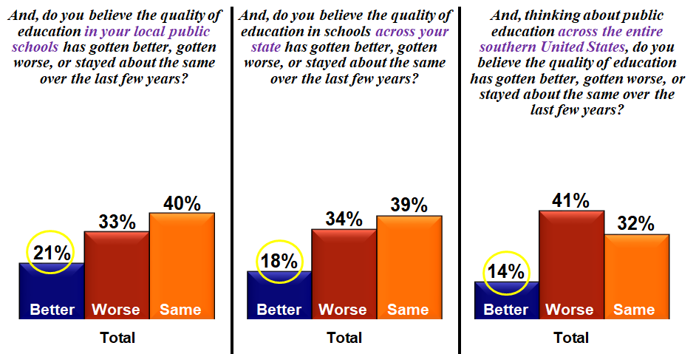

In the focus groups, voters bring up concerns over standardized test scores, too much "teaching to the test," and a real lack of focus on educating students on "real world skills."

Along these lines, there's significant frustration that standards are being "dumbed down" and instead of trying to lift kids up, schools are instead, pushing the bar down.

***Voters across the South prioritize providing an equal opportunity for children to get a good education, ensuring more effective teachers are in the classroom, and preparing high school students for the real world by teaching more real-life skills.***

In the survey, voters were asked to rate the importance of their state and local elected officials addressing many different aspects as it relates to K-12 public education. The most important priorities for voters included:

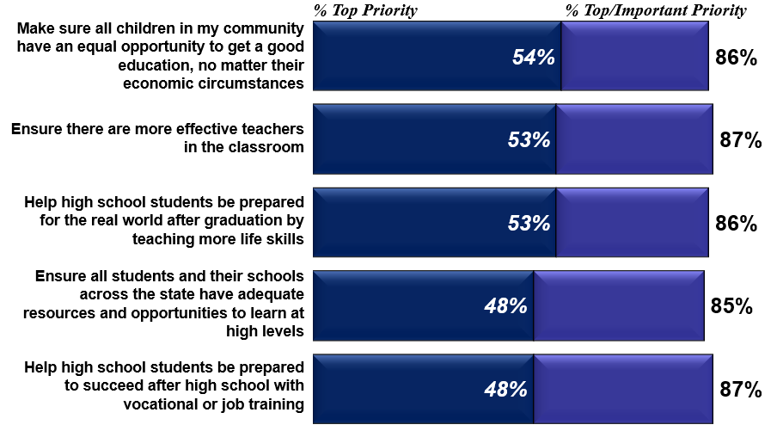

In their own words, voters in the focus groups reiterate these priorities by saying the purpose of public education is to:

*“prepare students to contribute to society”*

*“prepare students to be fully functioning adults in the real world armed with necessary skills”*

*“mentally prepare students for adulthood”*

*“give every child the opportunity to learn and better their lives”*

*“prepare the youth for adult life”*

*“prepare students the ability to live beyond graduation, whether that be college or a job”*

*“prepare children to be proactive, contributing members of society”*

*“educate young people for the working world”*

*“prepare youth for the real world”*

*“educate everyone equally”*

*“give children the opportunity to get an education and function in the real world”*

*“develop children to come out as successful and independent adults”*

*“provide a well-rounded education to prepare children for life/jobs”*

*“educate our kids to the best of our ability”*

*“promote well-rounded learning”*

***The term “equity” does not make voters think of differences in K-12 public education, though voters clearly articulate the concept.***

In our focus groups, voters have a hard time relating the term "equity" to public education. But, they certainly understand the concept and bring up inequities in the system organically.

While many have not seen, read or heard much about the term "equity" in education before, voters seem to "get it" during discussion and many respondents genuinely believe that schools vary across geographic areas due mostly to "money."

Interestingly, voters bring up "money" in a couple different ways:

* First, voters say that some schools just don't receive as much funding from their state or local governments. Along these lines, some voters believe that some schools just benefit from being from a more affluent area as the "tax base is higher."
* Second, voters believe that schools around higher-income areas tend to do better because parents in those locations have more disposable income that can be used to help the school - whether it's for the PTA, an athletic booster club, or for their own children to participate in more activities.

Importantly, voters immediately understand the consequence of inequities in schools.

They suggest that it harms the local economy as good companies and higher-paying jobs don't want to start-up or relocate to an area with poor schools. And, these voters believe it harms the kids, as colleges or even local employers tend to take students from better schools if all else is equal.

***Strong majorities of voters across the South recognize differences exist in how well students are educated across schools in their state AND how public schools are funded in their state.***

By a 74%-13% margin, voters believe “*differences in exist in how well students are educated across schools in their state*” versus “*public schools in their state to an adequate job of educating all students in schools across their state*.”

Voters across party lines, ethnicity, and geography strongly believe differences exist in education quality:

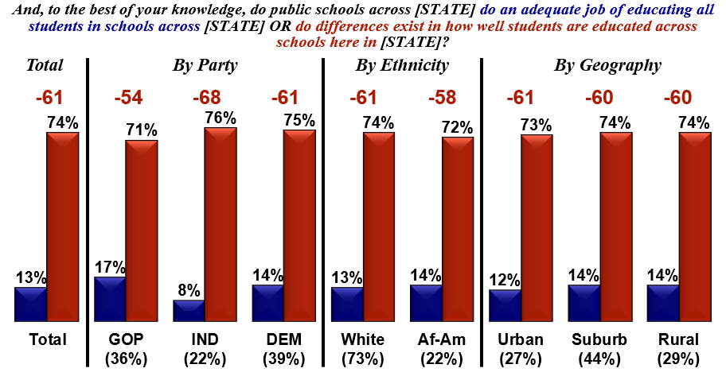

And, by a 64%-12% margin, voters believe “*differences exist in how schools are funded in their state*” versus “*public schools are funded at an even level*.”

Voters across party lines, ethnicity, and geography strongly believe differences exist in education funding:

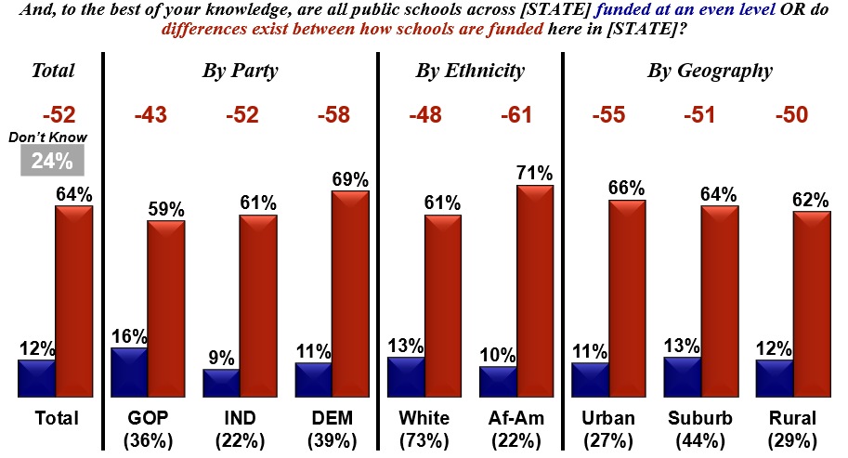

***As a result, there’s overwhelming support from voters across the South for addressing differences in education quality, funding, and ensuring greater fairness among poor and wealthier communities.***

By extremely wide margins, voters support the following:

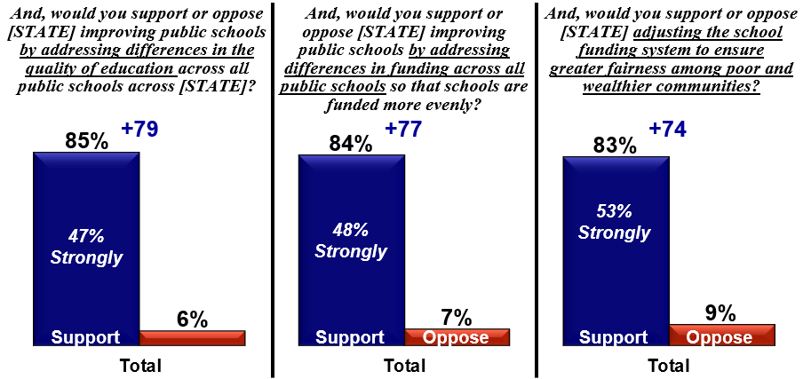

Given support levels in the 80% range, every key demographic and geographic group strongly supports addressing differences in education quality, funding, and ensuring greater fairness among poor and wealthier communities.

***To increase K-12 public education funding to improve equity in schools, there’s much stronger support for cutting government spending than to raise taxes.***

By a 71%-19% margin, voters would support “*cutting government spending on other issues to make K-12 public education a higher funding priority*.” Fewer voters (57%) would support “*increasing state taxes to pay for more K-12 public education funding*.”

And, there are clearly some differences by partisanship as just 49% of Republicans would support a tax increase compared to 74% of Republicans who would support re-prioritizing state spending.

In our focus groups, there's strong support among voters for higher education funding, but a tax increase receives very mixed feedback.

While nearly every respondent believes that schools need more funding, when probed about a tax increase to help reduce inequities between schools, the jury is out. Further, respondents from both groups would want any tax increase directly tied to education spending as some feel burned in the past by unkept promises by political figures.

By and large, if there IS more funding for schools, voters want that money to go to get better teachers and administrators, increase teacher pay, and to provide students with access to better computers and technology.

***Finally, the best way to talk about the importance of equity in public education is to demonstrate it is the responsibility of all and that to make sure everyone has the same opportunities regardless of their zip code.***

Voters were provided with several statements on why it’s important for there to be more equity in public education across their state, and asked to rate each on how convincing it is as a reason to improve public education.

The strongest scoring statements were:

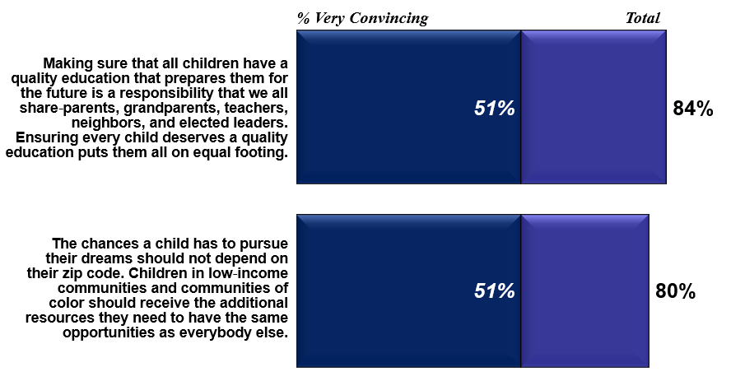

Other very strong scoring statements included:

